It’s time for our Annual Weber County Turkey/Ham/Food Drive!
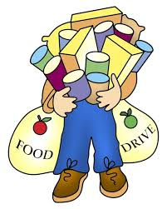
We want to make sure all our citizens
have a great Thanksgiving!
To make a difference this holiday season, please donate turkeys, hams and food items. Bring donations to the Commission Office by November 19th @ 10:00 a.m.
We will deliver them to the Joyce Hanson Hall Food Bank.
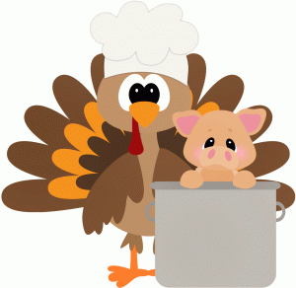
Thank you for your generosity!

